Question 17:
Store five planets and their distance from the Sun. Print each distance.
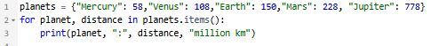
Output:
